**Assignment 9.2**

1)

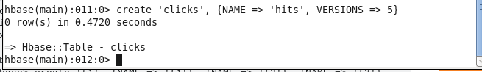

2)

